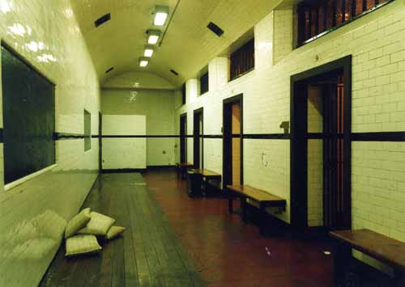**Town Hall Shooting Location Map (Updated)**

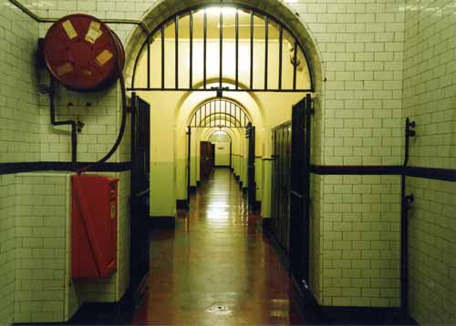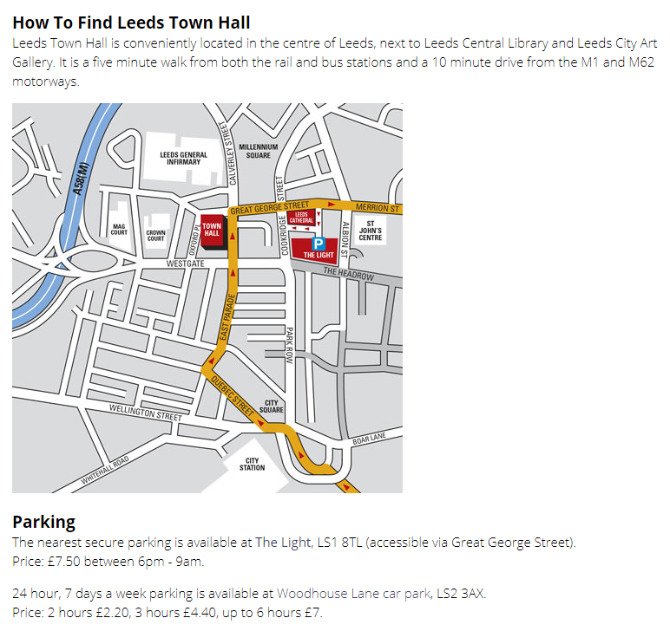**Corridors and Modern Cells**

From the reception desk, take a right and then your first left. Directly after this a **set of stairs** will be present to the right, follow them down and take a right again through a set of doors.

Walk straight and go through any of the doors at the end of the **large room** you’ve entered from the doorway you’ve just walked through.

Continue straight and walk through any of the doorways again to get to the **corridors** (second day shooting area).

The **modern cells** are located to at the right end of these corridors, after taking a left and a right turn through two narrow doorways. This is where we will store any personal belongings, equipment, food and props.

The **office location** (first day shooting location) is also situated at the **right end of the corridors,** just to the right.

**Victorian Cells**

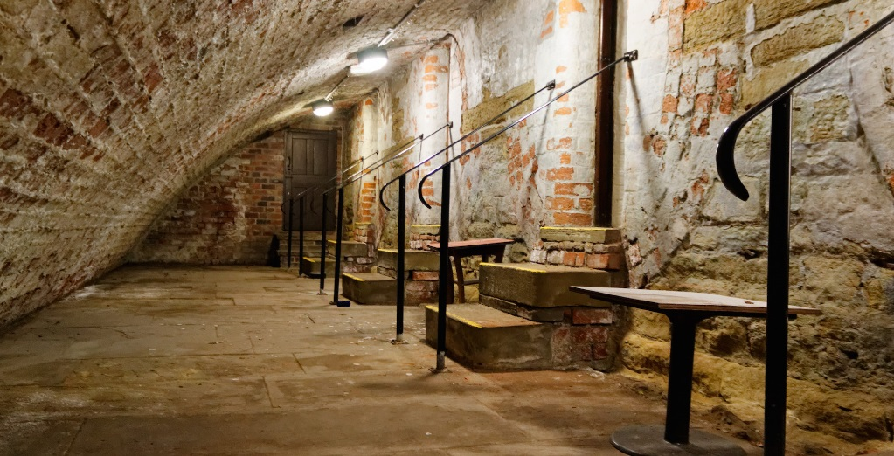

The **Victorian Cells** are found by taking a left turn when entering the **corridors** from the doorway led from the **large room.** Follow the corridor round until you reach an emergency exit door, take a right here