**Producers IT Organisational Processes**

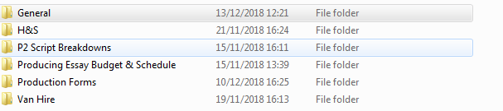**IT Documentation**

FOLDERS

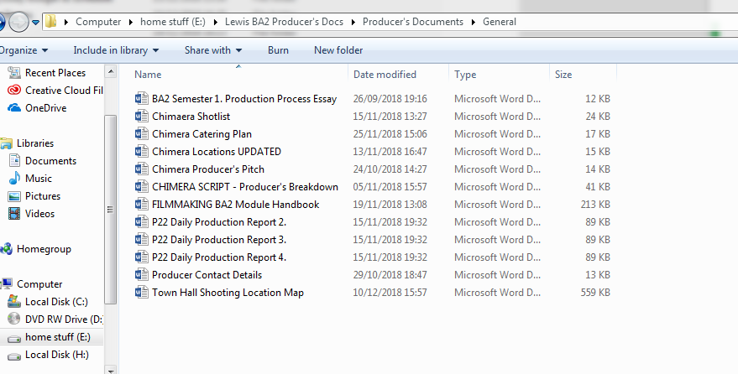

GENERAL DOCUMENTS

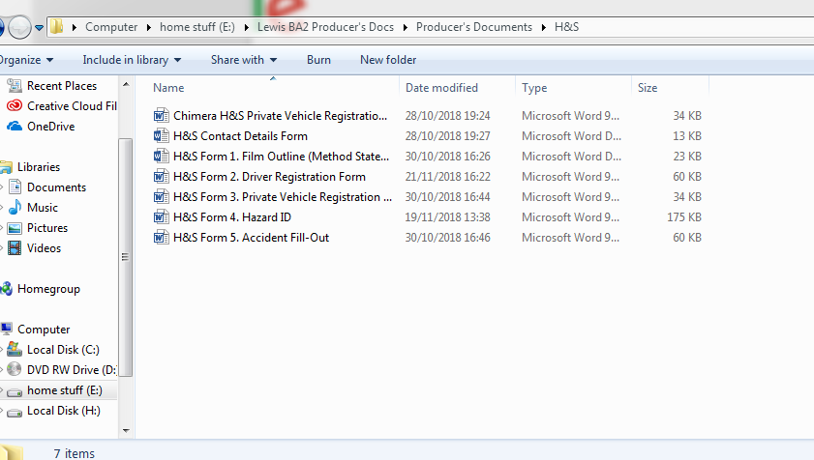

HEALTH& SAFETY

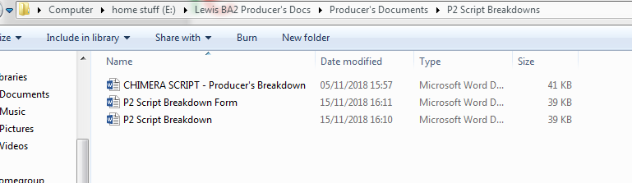

SCRIPT BREAKDOWNS

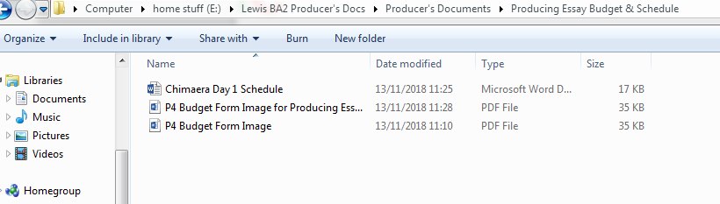

BUDGETS & SCHEDULES

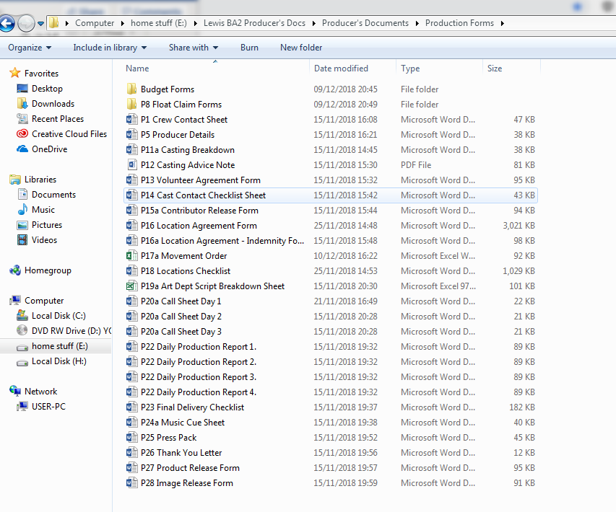

PRODUCTION FORMS

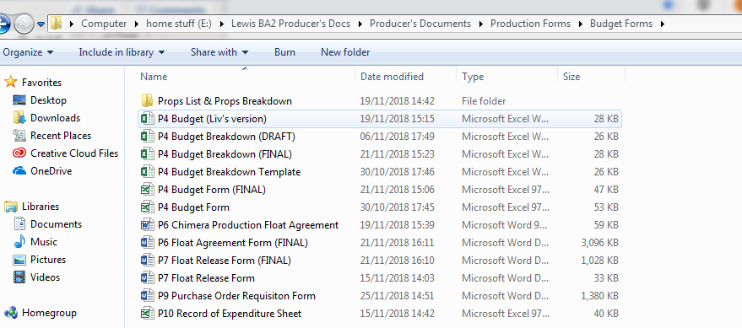

EXTERNAL PRODUCTION FORMS FOLDER: BUDGET FORMS

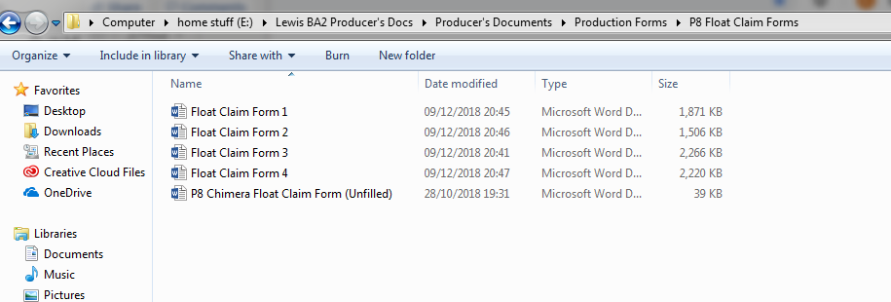

EXTERNAL PRODUCTION FORMS FOLDER: FLOAT CLAIMS

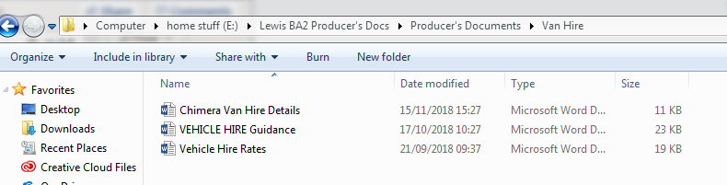

VAN HIRE FORMS

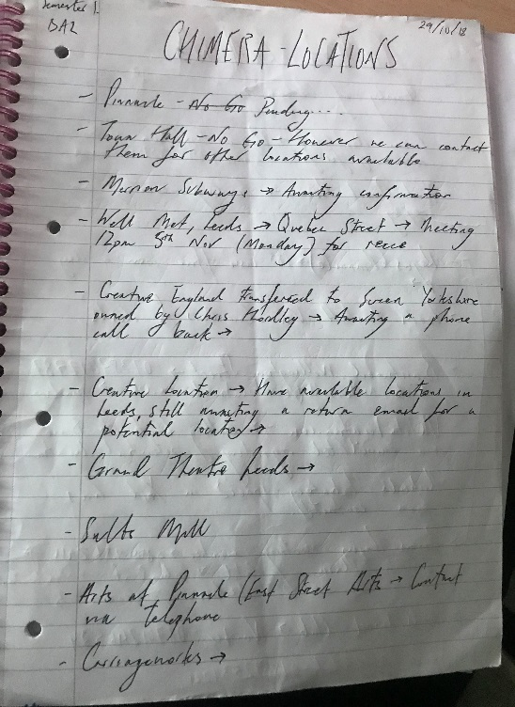**MEETING, TUTORIAL & LOCATION NOTETAKING**

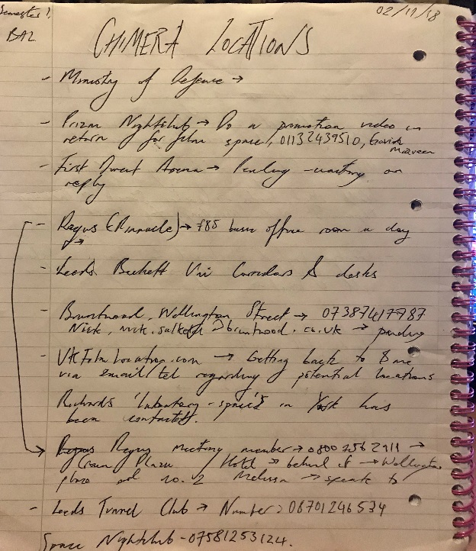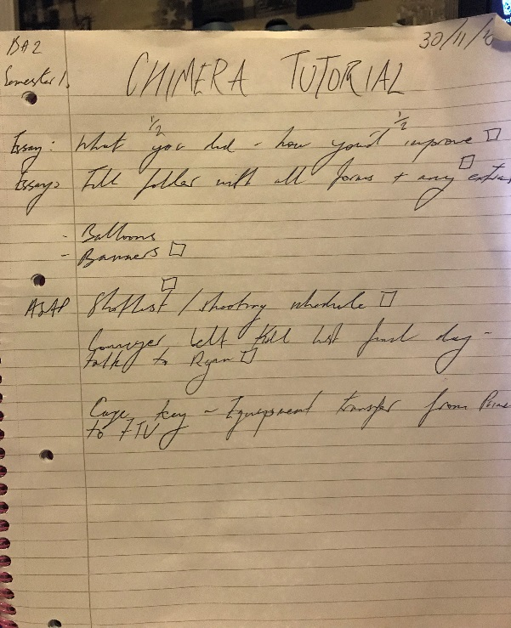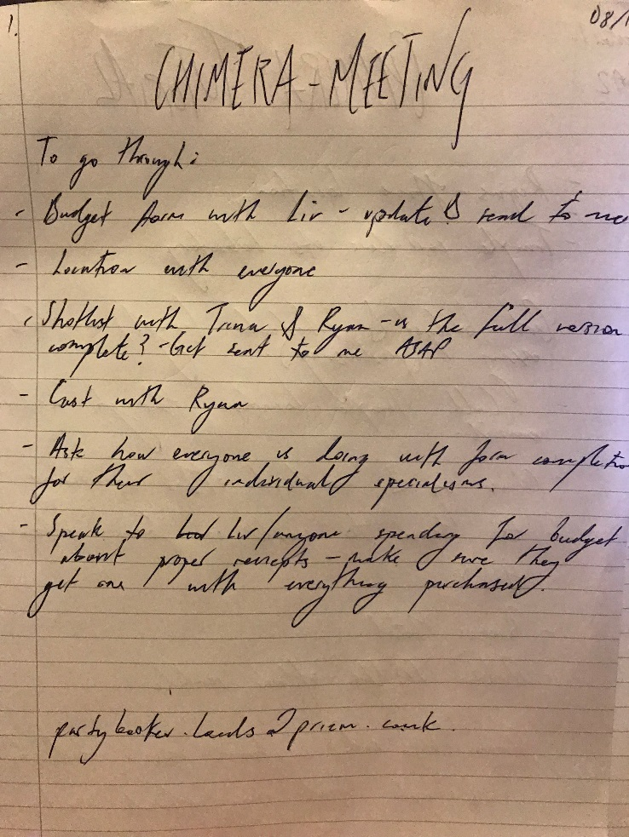

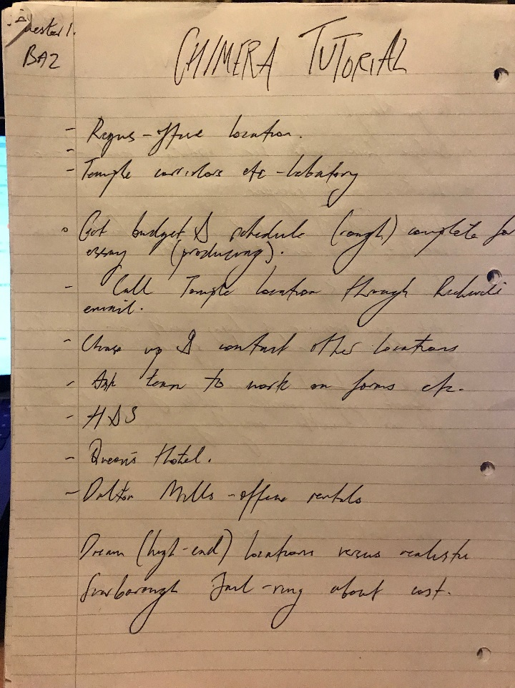

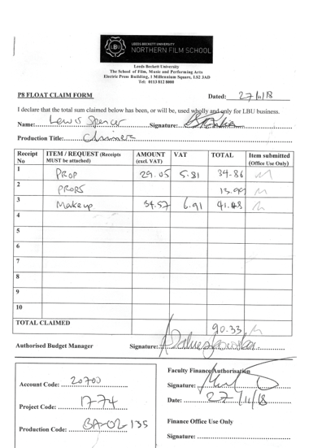**Budget Processes**

FLOAT CLAIM FORMS FILLED OUT MYSEKF ON BEHALF OF RECIEPTS SPENT BY MYSELF AND PRODUCTION DESIGNER.

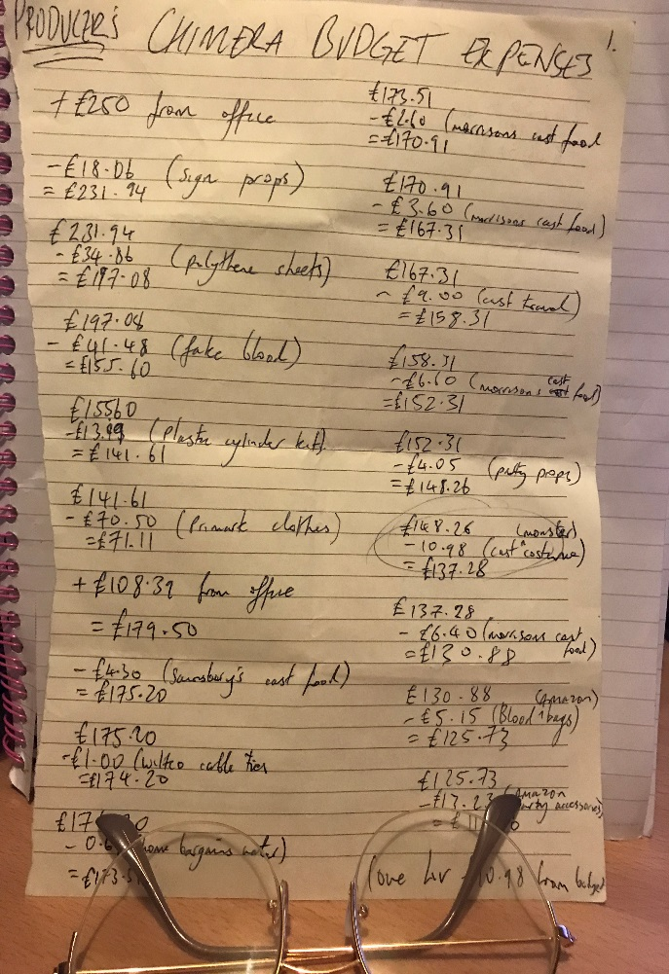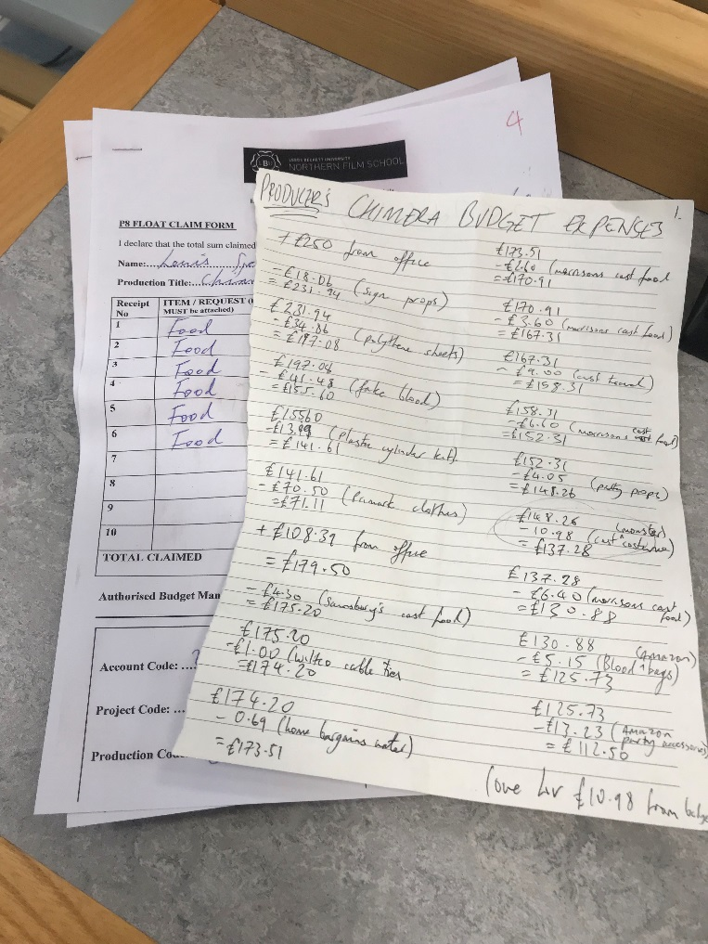

BUDGET BREAKDOWNS/NOTE-TAKING TO KEEP ON TOP OF EXPENDITURES

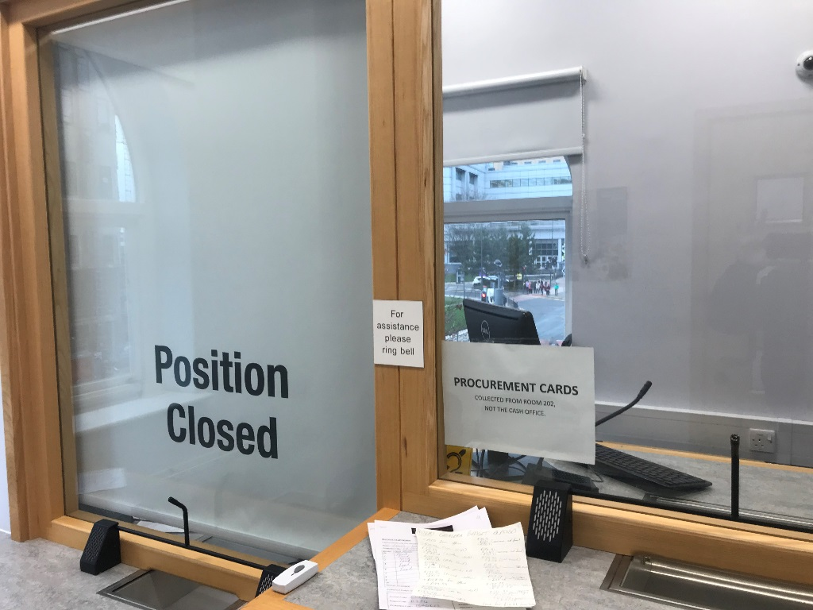

CASH OFFICE VISITS FOR RECEIVING BUDGET SPENDING MONEY

**PHONE CALLS & EMAILS TO EXTERNAL COMPANIES REGARDING LOCATION**



